- \(…)\Set-up robot\General
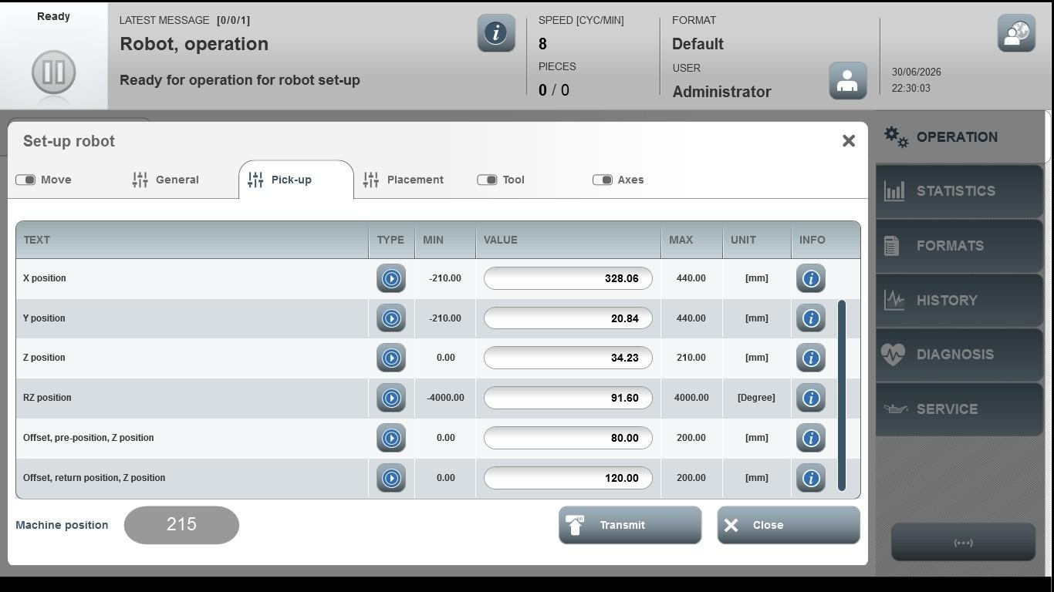
Acceptance criterion | Limits | Pass / Fail: Dev-No. | Date | Initials
Screen matches screenshot | N / A
Holding time during product pick-up | 0 … 200
Holding time during product placement | 0 … 200

